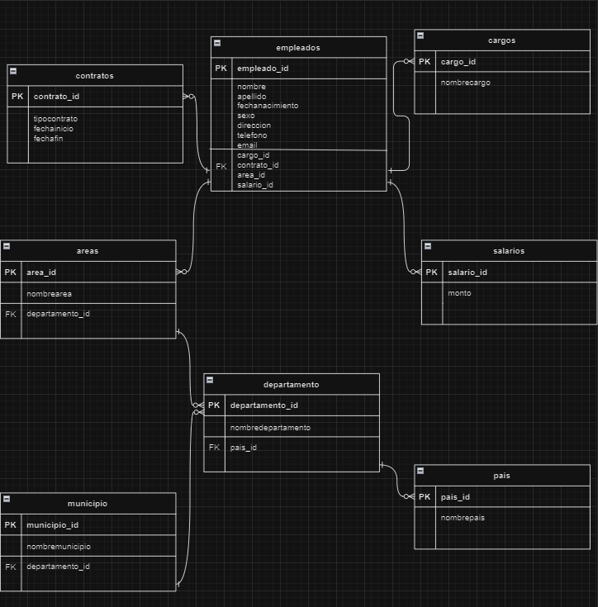

Link: https://drive.google.com/file/d/1r0kYxQizejnQER4MsLHlSbyL0vxzfc6n/view?usp=drive_link